Deputy Chief Fire Officer and Director of People

Job description and person specification

Devon and Somerset Fire and Rescue Service

Job description

Job Role/Size: Deputy Chief Fire Officer and Director of People
Job title: Brigade Manager
Reports to: Chief Fire Officer
Line manager responsibilities: ACO (Service Delivery) & ACO (Service Improvement)
Updated: Nov 2021

Main purpose of job:
The Deputy Chief Fire Officer (DCFO) will report to and support the Chief Fire Officer in leading the Service. As part of the Executive Board, they will assist in creating a vision, direction and culture of the Service which builds public trust and confidence through the delivery of effective services.

The DCFO will be directly responsible for the People function as well as the day to day management of the Service, ensuring that agreed policies are implemented effectively and performance managed. The post holder will deputise for the CFO as and when required.

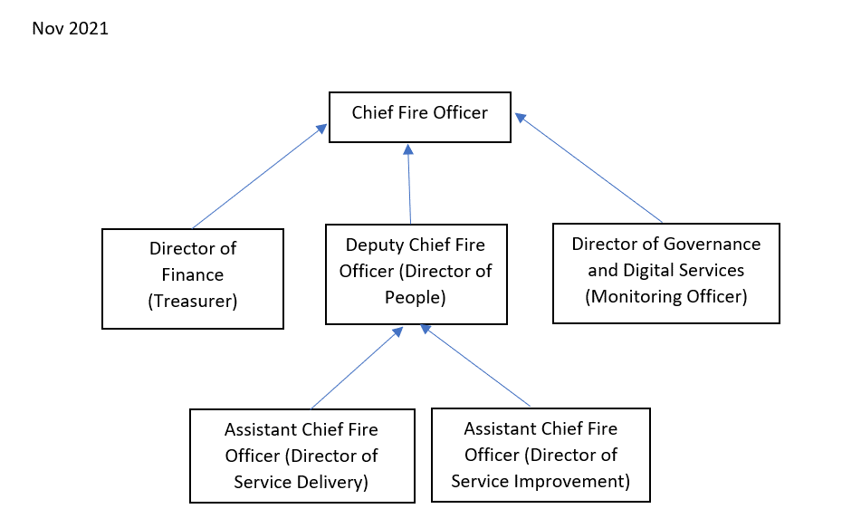

Main responsibilities and duties:
- To deputise in the Chief Fire Officers absence.
- To inform new policies and strategies to improve the organisation for approval.
- To deliver strategies in accordance with agreed policies.
- Prior to the recruitment of a Director of People, to manage the strategic HR function (including employee relations issues), commissioning external support as appropriate.
- To drive improvements including delivery of the HMICFRS action plan.

Generic Role Map responsibilities:
Provide strategic advice and support to resolve operational incidents
As part of this responsibility you will be required to:
• Evaluate service responses to incidents.
• Advise and support those involved in resolution of incidents.
• Liaise with media and other agencies to achieve strategic objectives.
• Debrief following resolution of incidents.
National Occupational Standards (NOS): EFSM 1
Job specific responsibilities:
• Take command of major operational incidents.
• Provide effective management and strategic advice and support to resolve operational incidents.

Lead, Monitor and Support people to resolve operational incidents
As part of this responsibility you will be required to:
• Review and determine incident status.
• Assume responsibility and implement action to support those involved in the incident.
• Debrief following resolution of the incident.
National Occupational Standards (NOS): EFSM 2
Job specific responsibilities:
• Lead, monitor and support people to resolve operational incidents.

Plan organisational strategy to meet agreed aims and objectives
As part of this responsibility you will be required to:
• Agree organisational aims, objectives and measures of performance.
• Establish factors within internal and external operating environments that influence strategic direction and planning.
• Secure resources required to meet stated aims and objectives.
• Produce a strategic plan to meet agreed aims and objectives.
National Occupational Standards (NOS): EFSM4
Job specific responsibilities:
• As a member of the Executive Board and a Principal Officer, contribute to the development of the organisational goals and objectives and the Corporate Plan.
• To provide strategic direction for Service Response, Protection and Prevention.

Plan implementation of organisational strategy to meet objectives
As part of this responsibility you will be required to:
• Develop and agree policies and processes to support achievement of organisation aims and objectives.
• Establish and agree the optimum organisation structure to support achievement of aims and objectives.
• Produce implementation plans to achieve organisation strategy.
National Occupational Standards (NOS): EFSM 5
Job specific responsibilities:
• Provide strategic leadership to ensure the achievement of corporate aims and objectives and that performance management is embedded in all activities of the Service.
• Contribute to the formation of policies and procedures for the organisation, taking the strategic lead for Service Response, Protection and Prevention.

Evaluate organisational performance against agreed measures
As part of this responsibility you will be required to:
• Measure organisational performance against operational targets.
• Measure the effectiveness of the organisation in achieving strategic goals.
• Evaluate overall performance and take action to rectify actual or potential shortfalls.
National Occupational Standards (NOS): EFSM7
Job specific responsibilities:
• Ensure that Service Response, Protection and Prevention operate effectively and efficiently within existing budgets to fulfil our objectives, achieve best value targets and facilitate continuous improvement.

Lead organisation strategy through effective decision making
As part of this responsibility you will be required to:
• Obtain information required to enable effective decision making.
• Communicate decisive action to achieve strategic goals.
National Occupational Standards (NOS): EFSM 8
Job specific responsibilities:
• Establish and maintain good working relationships with elected members and provide advice, information and technical expertise on matters relating to their statutory responsibilities and other non-statutory duties.

Select personnel for employment
As part of this responsibility you will be required to:
• Identify personnel requirements.
• Select required personnel.
National Occupational Standards (NOS): EFSM 13
Job specific responsibilities:
• Contribute to Service-wide workforce planning.
• Support the recruitment and promotion process for senior positions through the short-listing, chairing and participating in selection panels as appropriate.

Manage the performance of teams and individuals to achieve objectives
As part of this responsibility you will be required to:
• Allocate and delegate work to teams and individuals.
• Agree objectives and work plans with teams and individuals.
• Assess the performance of teams and individuals.
• Provide feedback to teams and individuals on their performance.
• Resolve performance problems with teams and individuals.
National Occupational Standards (NOS): EFSM 14
Job specific responsibilities:
• Responsible for the effective management of teams by providing support, guidance and feedback and resolving any performance issues.
• Develop teams and individuals to improve performance.
• Ensure development of personal skills and behaviours aligned to the Service Core Values and Behavioural Framework.
• Act as a Senior Point of Contact for disciplinary and grievance matters and chair meetings as appropriate.
Develop teams and individuals to enhance work based performance
As part of this responsibility you will be required to:
• Identify the development needs of teams and individuals.
• Plan the development of teams and individuals
• Develop teams to improve performance.
• Deliver individual learning and support for development.
• Evaluate the development of teams and individuals.
National Occupational Standards (NOS): EFSM 15
Job specific responsibilities:
• Promote effective communication and team working to ensure the delivery of service aims and objectives.
• Ensure that development reviews are conducted for all staff within Service Delivery and Community Safety Departments.
• Ensure that training needs are developed and training plans created.

Manage yourself to achieve work objectives
As part of this responsibility you will be required to:
• Organise and structure personal work activities to achieve objectives.
• Develop and continuously improve productive working relationships.
• Implement personal development plan to continuously improve personal performance.
National Occupational Standards (NOS): EFSM 16
Job specific responsibilities:
• Identify workload priorities, SMART personal objectives and key working relationships necessary to achieve success in the role.
• Identify training and educational opportunities for continuous personal and professional development.
• Acquire/maintain all qualifications and certificates as required by Service policy.

Exchange information to ensure effective service delivery
As part of this responsibility you will be required to:
• Plan and chair meetings to aid decision making.
• Participate in meetings relating to service delivery.
National Occupational Standards (NOS): EFSM 20
Job specific responsibilities:
• Develop and maintain effective working relationship with national bodies, other agencies, organisations, Trade Unions and Fire & Rescue Services to promote the work of Devon & Somerset Fire and Rescue Service and the achievement of safe and secure communities.
• Organise, chair and participate in appropriate strategic meetings to support effective working with internal/external stakeholders. Follow up and communicate agreed action plans and review effectiveness of the meetings.

Drive, manoeuvre and redeploy fire service vehicles
As part of this responsibility you will be required to:
• Drive vehicle to incidents.
• Manoeuvre, site and re-deploy vehicles.
National Occupational Standards (NOS): FF9

