Introduction
- The Devon & Somerset Fire & Rescue Authority (the Authority) covers a diverse geographical area across two counties; with large towns and cities, market towns and isolated rural areas together with major roads and two extensive lengths of coastline. The current budget (2022-23) of £77.3m is used to resource 83 fire stations, 112 fire engines in addition to numerous special appliances. Around 1,800 staff deliver fire prevention and protection activity, respond to emergency calls and incidents and provide professional support functions. The Authority is progressing well in making a significant investment in our On Call service. The COVID-19 pandemic is already increasing pressure on public service finances and its impacts are likely to be felt for some years to come.
1.2 This document is the Medium-Term Financial Plan and outlines funding, income and expenditure forecasts for the next five years. The Medium-Term Financial Plan will be updated annually as part of the budget setting process and will be refreshed more frequently if information which makes a material difference becomes available. Understanding the Authority’s finances is really important when making decisions about the future and this document should be read alongside the Authority’s Community Risk Management Plan and Reserves Strategy together with the Safer Together Programme.

Funding and Income
- The Authority has three main sources of revenue funding:
- Council Tax Precept;
- National Non-Domestic Rates Scheme; and
- Revenue Support Grant.
- Additionally, income from one-off grants, recharges and services is offset against our expenditure in order to reach the “net revenue budget” in each year.

Building the Medium-Term Financial Forecast
Planning for different scenarios
- The forecasts in this document represent a “base case” scenario built on the latest information from government, sector knowledge and experience of finance officers. “Worst case” and “best case” scenarios are also developed to show the impact of various funding and cost pressures.
- In the Worst case, government grants are frozen, pay and inflation see a steep increase, additional pensions costs arise, council tax is frozen and the base continues to remain as is with no growth and a very modest mid-period increase in council tax collection surplus.
- In the Best case, government grants, pay and inflation remain steady, pension costs are funded and Council tax is increased every year, with the council tax base achieving modest growth.
- In the Base case, which is presented here, government grants rise with inflation, pay and inflation remain steady, pension costs are minimal and council tax losses are minimised. This is considered the most likely scenario.
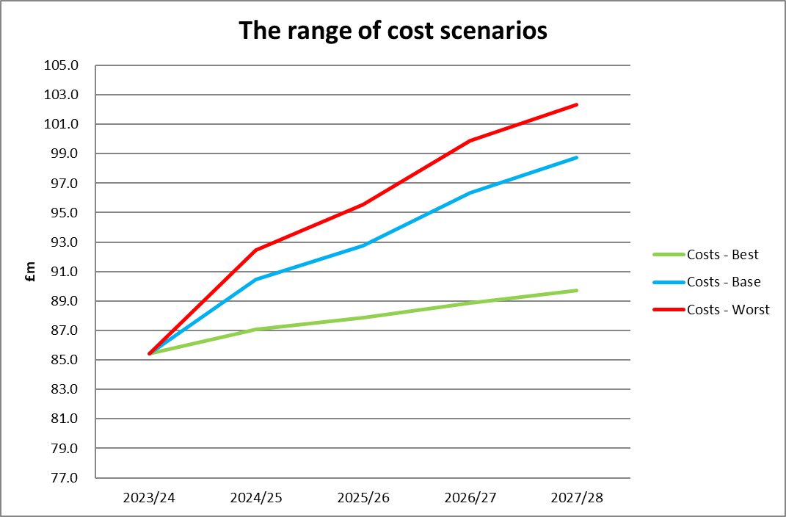
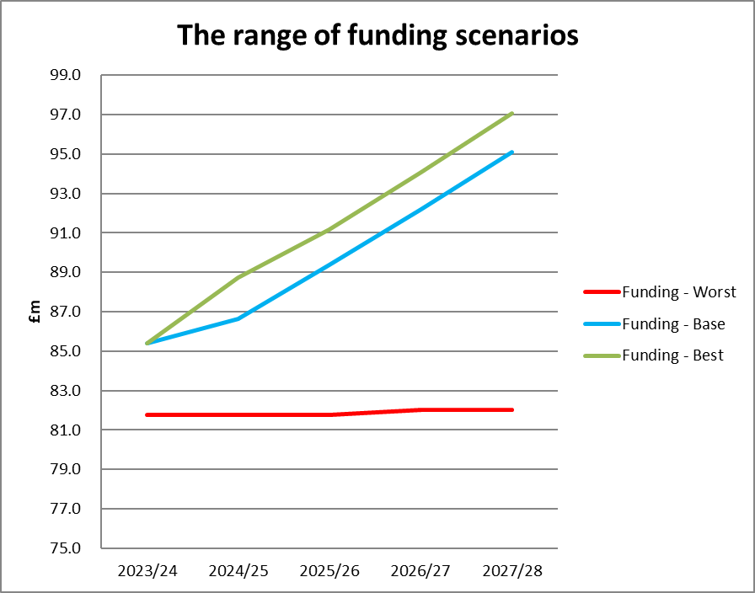
- The Base case is presented to the Authority with options over council tax and where savings targets are fed back into the budget setting process each year.

- The range of scenarios presented in the charts above demonstrates that the savings gap (the difference between funding and costs) could vary from a deficit of £20.3m to a benefit of £7.3m over the next five years. The base case £15.7m gap) represents the most likely scenario and informs the Medium-Term Financial Plan. Because the Plan is reviewed annually, variations can be built in and projections are refined at regular intervals, short term exceptions can also be smoothed out using reserves.
Funding
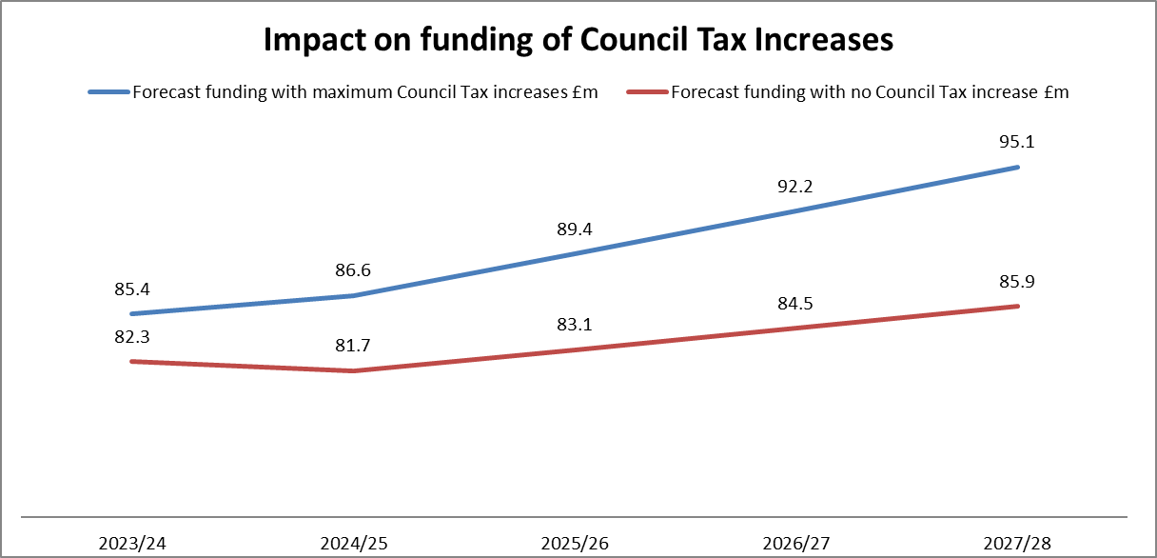
- When building the five year forecast, assumptions are made about each of the funding sources and how they may change in the coming years. A range of scenarios can then be used to calculate the anticipated funding available. The Authority only has direct control over the level of Council Tax raised each year and the following graph shows the impact on funding of maximum raises against no increases, which could amount to a difference of 9.2m over the next five years.

Expenditure
- Assumptions are also made about forecast expenditure. The Authority can control some of its costs by managing its budget effectively; other elements are dependent on national drivers such as inflation, superannuation (pension) costs and pay awards. Expenditure is shown in the chart overleaf which highlights that 78.1% of Service costs are related to employees, meaning that increases in this area can have a significant impact on the budget. The Capital Programme is also paid for through Revenue funds; a combination of money set aside to pay for historic borrowing, budget provision to fund future capital expenditure and Reserves designated for Capital Use.
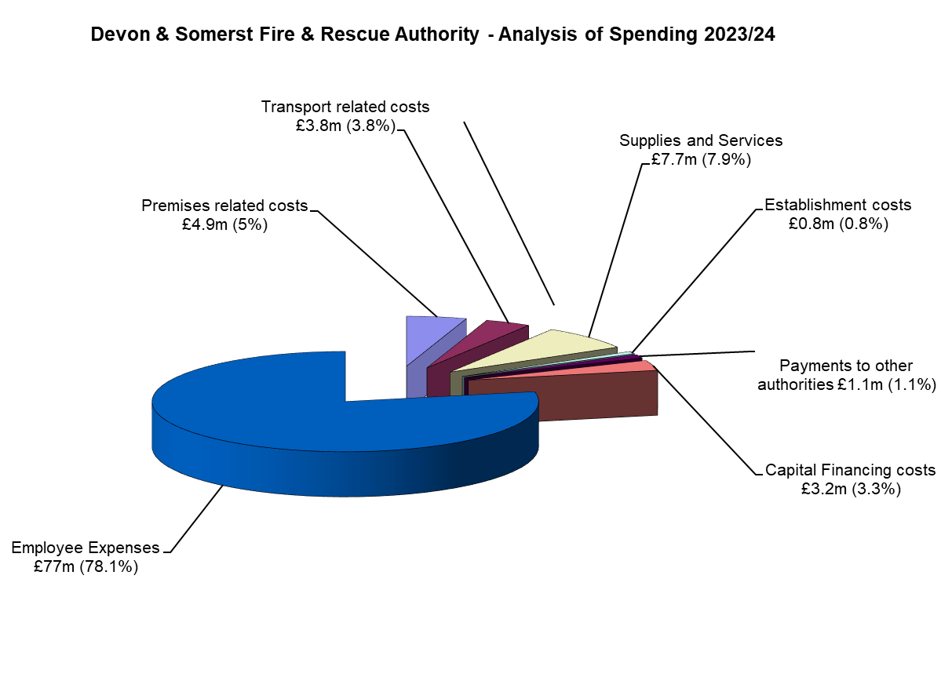
Cost Pressures
- The medium-term financial forecast identifies the following cost pressures within the next five years which are added to the current budget to reach the future budget requirement:
- Pay increases
- Inflation
- Pension increases
- Reduction to one-off grant income
- Capital investment
Savings targets and the Target Operating Model
- The chart overleaf shows the gap between potential funding available versus the budget requirement, including cost pressures. This is known as the funding gap. Over five years the funding gap could reach £20.8m if Council Tax is frozen, falling by £8.6m if increased in line with assumed referendum limits (i.e. 1.99%) set by HM Treasury.
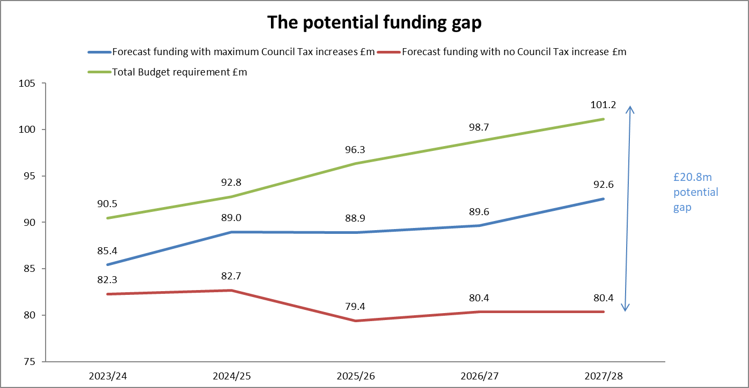
- The Authority has an excellent history of achieving savings targets, with over £22.5m saved over the since 2011-12 to 2022-23.
- Given the big challenge posed by the funding gap and the need to reform the Service, plans have been approved to future-proof the organisation and deliver budget savings. The Community Risk Management Plan will define the Service high-level strategy alongside the creation of a Target Operating Model (TOM) which will align the Service workforce in the most efficient and effective way.

Meeting the funding gap
- Following on from efforts to realign resources to risk, focus will now be placed on efficiency of the Service through:
- Development of a revised Estates Strategy and rationalisation of buildings;
- Smarter working and continued Digital Transformation;
- Reviewing whether supporting functions are achieving value for money and exploring alternative delivery models; and
- Exploring opportunities to improve the productivity of Service staff and assets.

CONCLUSION
- The medium-term financial forecast is indicating significant budget pressures over the next five year period and robust plans must be made to meet the challenge. The Service is progressing well with change plans and will need to identify further benefits within the next year to ensure longer term financial sustainability. In addition to savings realised from the Safer Together programme, ongoing work will be done to reduce costs through budget management, procurement, collaboration and efficiency reviews.
APPENDIX A TO REPORT DSFRA/23/

GLOSSARY AND METHODOLOGY FOR CALCULATING ASSUMPTIONS
Council Tax Precept. Each household receives an annual Council Tax Bill which is made up of charges for various services such as County, Unitary, District and Parish Councils, Police and Fire. The charge is known as the Council Tax Precept and is determined by the Authority each year and is usually quoted as the amount for a Band D property. In Devon & Somerset there are 14 billing authorities made up of district and unitary councils and those bodies are responsible for sending out bills to households and collecting the money which is then paid over to the Authority.
Council Tax income received in each year is based on three elements and these are forecast separately:
- The amount of Council Tax Precept that each household pays is set by the Authority each year and in 2022-24 is subject to a maximum of £5 increase (any increase above that level would require a local referendum to be held).
- The number of households in the area (the Council Tax Base) which is estimated based on housing growth.
- The success of billing authorities in collecting their Council Tax; each authority will have a surplus or deficit on their collection fund, a proportion of which is passed on to the Authority (Council Tax Surplus/Deficit). NOTE: These figures have been impacted due to COVID-19
National Non-Domestic Rates, also known as Business rates retention scheme, is made up of two elements; a proportion of business rates collected by billing authorities and paid directly to the Authority and a “Top-up grant” from central government which is intended to make up the difference between the Authority’s baseline funding and actual income (calculated by central government based on a proportion of total business rates funding across the fire sector).
National Non-Domestic Rates income received in each year is based on three elements and these are forecast separately:
- The amount of Business Rates Income
- The success of billing authorities in collecting their Business Rates; each authority will have a surplus or deficit on their collection fund, a proportion of which is passed on to the Authority (Surplus/Deficit)
- The amount of Top-Up Grant due to the Authority which is notified by central government annually
Revenue Support Grant is received directly from central government and is based on the Settlement Funding Agreement which is determined based on analysis of spending requirement across English Fire Services. The Settlement Funding Agreement can be set annually or for a longer period. A one year settlement was made for 2023-24. Beyond that period assumptions have to be made as to the level of grant income to be received.

Section 31 Grants are made from central government and determined on an annual basis. The biggest grants for the Authority are Small Business Rates Relief (reimbursement from the government for reduced business rates income), Rural Services and Transition Grants.
Grants, Reimbursements and Other Income. The Service undertakes a range of activities outside of its statutory duties, some of which are paid for by third parties. This can include Co-responding to Ambulance Service incidents, rent on our premises and running training courses.
Cost Pressures:
Pay Awards are subject to agreement by the relevant National Joint Council (pay bodies for public sector) and apply to English and Welsh Fire and Rescue Authorities. Pay awards are often agreed annually within the financial year they apply and are therefore subject to variation against the forecast. Assumptions are benchmarked against the Fire Sector at least annually.
Inflation. The Authority is responsible for funding inflationary increases. The rate is set for pensions on an annual basis and prices for goods and services may fluctuate depending on the contract in place for purchasing them.
Superannuation. The Authority is responsible for paying employer pension contributions (also known as superannuation) which are based on a percentage of pensionable pay. There are several pension schemes for firefighters and support staff and the employer contribution percentage rates are determined every three years via an actuarial valuation. Superannuation currently accounts for around 20% of expenditure on employee costs so variations to rates can have a significant impact. Estimated increases are included in the Medium Term Financial Plan as a cost pressure.
Capital Programme. Significant purchases of assets costing £20,000 or more with a useful life beyond one year are classified as Capital expenditure. Can include purchasing vehicles and equipment, building new stations, extensions and major refurbishment, as well as ICT infrastructure.

